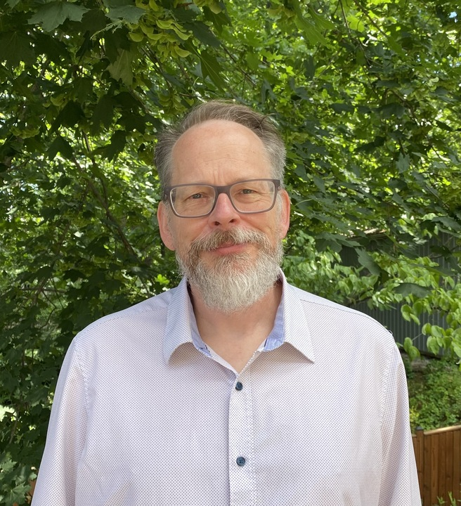
Succinct:

Dr. Tim Oates is a distinguished AI and machine learning expert with over 25 years of experience as both a researcher and practitioner. As Chief Data Scientist at Synaptiq, he bridges the gap between cutting-edge academic research and practical business applications, leading AI strategy development and providing expert consultation to clients across industries. Tim has published more than 150 peer-reviewed papers spanning time series analysis, natural language processing, computer vision, and medical informatics. He is an Oros Family Professor of Computer Science at the University of Maryland, Baltimore County, and holds a Ph.D. in Computer Science from the University of Massachusetts, Amherst.

Extended:

Dr. Tim Oates is a seasoned AI and machine learning leader with over 25 years of experience driving innovation across academia and industry. His expertise spans artificial intelligence, machine learning, natural language processing, computer vision, and data science, with deep specialization in translating complex research into scalable business solutions. As Chief Data Scientist at Synaptiq, Tim leads AI strategy development and implementation, directs teams in the development and deployment of AI models, and provides expert consultation to clients seeking to harness AI for measurable business value.

Tim's recent consulting work reflects the breadth and depth of his applied AI expertise. His projects include optimizing days to collect revenue in finance using machine learning, automating eligibility determination in healthcare through machine learning and NLP, applying deep learning to cybersecurity graph analysis, improving customer experience through recommender systems, and increasing revenue from job boards using machine learning and NLP. This hands-on delivery experience, combined with his academic rigor, gives him a rare ability to design AI solutions that are both technically sound and practically impactful.

Prior to his current role, Tim served as Chief Scientist at CircleBack (now SalesIntel), where he pioneered the transition to AI-driven contact data management and oversaw the development of entity extraction, linking, and resolution algorithms at scale. He was also a postdoctoral associate in the MIT Artificial Intelligence Lab, where he deepened his expertise in foundational AI research. His career-long commitment to both advancing the science of AI and applying it to real-world problems gives him a unique perspective on what it takes to move from prototype to production.

Tim is a prolific researcher and thought leader in AI, having authored more than 150 peer-reviewed publications on topics including time series analysis, sequence mining, relational and graph mining, and medical informatics. He is an Oros Family Professor of Computer Science at the University of Maryland, Baltimore County, where he teaches graduate and undergraduate courses in machine learning, AI, and robotics. Tim holds a Ph.D. and M.S. in Computer Science from the University of Massachusetts, Amherst, and dual B.S. degrees in Computer Science and Electrical Engineering from NC State University.
